**1.What are the two values of the Boolean data type? How do you write them?**

Ans: True and False.

x= True, y= False

**2. What are the three different types of Boolean operators?**

Ans: And 🡪 True if both are true 🡪 x and y

Or 🡪 True if atleast one is true 🡪 x or y

Not 🡪 True only if false 🡪 not x

**3. Make a list of each Boolean operator's truth tables (i.e. every possible combination of Boolean values for the operator and what it evaluate ).**

**AND Tables**

|  |  |  |  |  |
| --- | --- | --- | --- | --- |
| **X** | **AND** | **Y** | **=** | **OUTPUT** |
| **True** | **AND** | **True** | **=** | **True** |
| **True** | **AND** | **False** | **=** | **False** |
| **False** | **AND** | **True** | **=** | **False** |
| **False** | **AND** | **False** | **=** | **False** |

**OR Tables**

|  |  |  |  |  |
| --- | --- | --- | --- | --- |
| **X** | **or** | **Y** | **=** | **OUTPUT** |
| **True** | **or** | **True** | **=** | **True** |
| **True** | **or** | **False** | **=** | **True** |
| **False** | **or** | **True** | **=** | **True** |
| **False** | **or** | **False** | **=** | **False** |

**Not Table:**

|  |  |  |  |
| --- | --- | --- | --- |
| **NOT** | **Variable** | **=** | **Output** |
| **Not** | **True** | **=** | **False** |
| **Not** | **False** | **=** | **True** |

**4. What are the values of the following expressions?**

(5 > 4) and (3 == 5)🡪 False

not (5 > 4)🡪 False

(5 > 4) or (3 == 5) 🡪 True

not ((5 > 4) or (3 == 5))🡪False

(True and True) and (True == False)🡪False

(not False) or (not True)🡪True

**5. What are the six comparison operators?**

== , >, <, !=, >=, <=

**6. How do you tell the difference between the equal to and assignment operators? Describe a condition and when you would use one.**

==🡪 Equal to operator (Used to compare two values. Returns 1 if true else 0)

= 🡪 Assignment operator (Used to assign different values to variables)

**7. Identify the three blocks in this code:**

spam = 0

if spam == 10:

print('eggs') --------------🡪 Block 1

if spam > 5:

print('bacon')------------🡪 Block 2

else:

print('ham')-------------🡪 Block3

print('spam')------------🡪 Block 3

print('spam')------------🡪Block3

**8. Write code that prints Hello if 1 is stored in spam, prints Howdy if 2 is stored in spam, and prints Greetings! if anything else is stored in spam.**

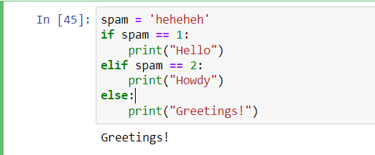

**9.If your programme is stuck in an endless loop, what keys you’ll press?**

Cntrl + C

**10. How can you tell the difference between break and continue?**

Break 🡪 Used to exit out of the loop and stop the flow of execution

Continue🡪Used to reject all the remaining statements in current loop and returns the control to the top of the loop(while/for)

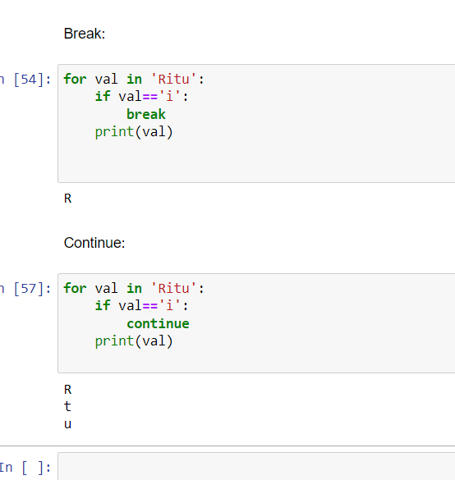

**11. In a for loop, what is the difference between range(10), range(0, 10), and range(0, 10, 1)?**

range(start, stop, increment)

range(10)- by default start =0, increment =1 , so it returns sequence of numbers starting from 0 to 10-1(9)

range(0,10)- returns numbers starting from 0 to 10-1(9), taking increment as 1 by default

range(0,10,1) -returns 0 to 9 as we have explicitly provided increment as 1 and start point=0

12. Write a short program that prints the numbers 1 to 10 using a for loop. Then write an equivalent program that prints the numbers 1 to 10 using a while loop.

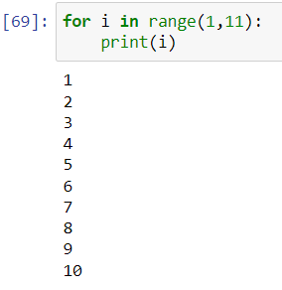 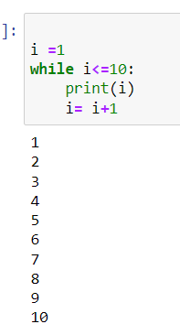

**13. If you had a function named bacon() inside a module named spam, how would you call it after importing spam?**

Import spam

x.Spam.bacon()

Or

From spam import *

x.spam()